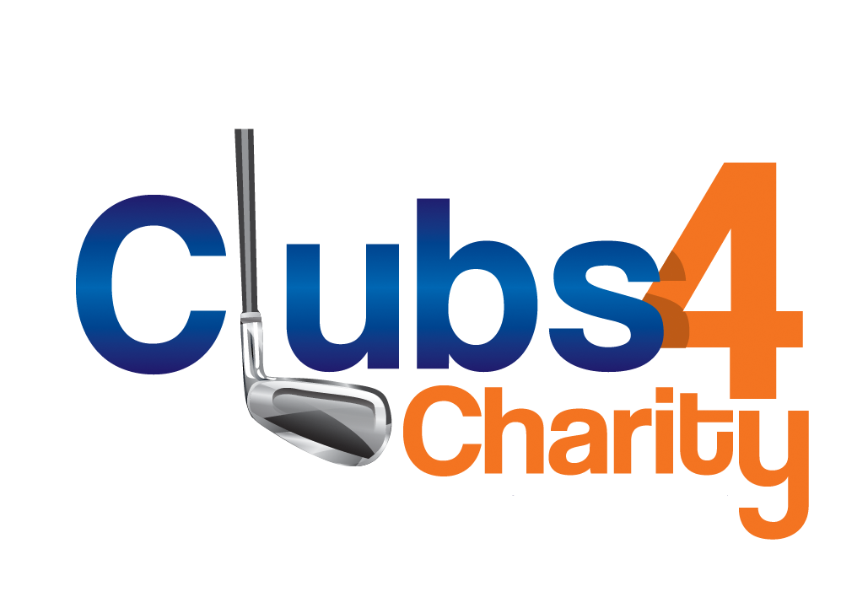
Clubs 4 Charity, a division of iGolf Value Guide, presents a revolutionary fundraising approach. Our Golf Club Drive allows your organization to take advantage of the untapped value of unwanted, used golf clubs that are collecting dust in every golfer's garage. These golf clubs are eagerly awaiting to be cleaned and recycled, all in support of your noble cause. Tournament Organizers, just imagine the impact of having 100 golf participants generously donate their used putters, wedges, or even complete sets of clubs. It's truly remarkable how thousands of dollars could be raised without even having to ask anyone for money.

Charity of Choice
Charity’s Name:
Street Address: | City, State, Zip:
Item(s) Donated:
Value (determined by iGolf Value Guide): | Check #, Date Mailed:
Donor
Donor’s Name:
Country Club Contact:
Address:
City: | State, Zip:

Donor requests the donation receipt be mailed to address above.
77551 El Duna Ct, Ste C., Palm Desert CA 92211, 855-678-6737
www.iGolfValueGuide.com

